LAB

REPORT-01

IRE 106: Electronics Devices and Applications Sessional

|  |  |
| --- | --- |
| PREPARED BY  ID:  2101013,  2101027,  2101028  Session: 2021-2022  Date: 30/01/2024 | SUPERVISED BY  Sadia Enam  Lecturer  Department of IRE, BDU |

|  |  |
| --- | --- |
| logo1 | BANGABANDHU SHEIKH MUJIBUR RAHMAN DIGITAL UNIVERSITY  (BDU) |

**Experiment No.: 01**

**Experiment Name:** **Study and Observation of Half Wave Rectifier.**

**Objective:**

● Capture the output waveform on the oscilloscope.

● Analyze the waveform to understand how the half-wave rectifier converts AC to DC.

● Measure and record the peak voltage (Vpeak) of the rectified waveform.

**Theory:**

A half-wave rectifier is a circuit that converts an AC input voltage into a pulsating DC output voltage by allowing only one half of the input waveform to pass through. It is commonly used in power supply circuits.

**Required Apparatus:**

● A Diode

● A AC Voltage Supply

● A load (Resistor)

● An Oscilloscope

● A Ground Terminal

● Wire

**Circuit Diagram:**

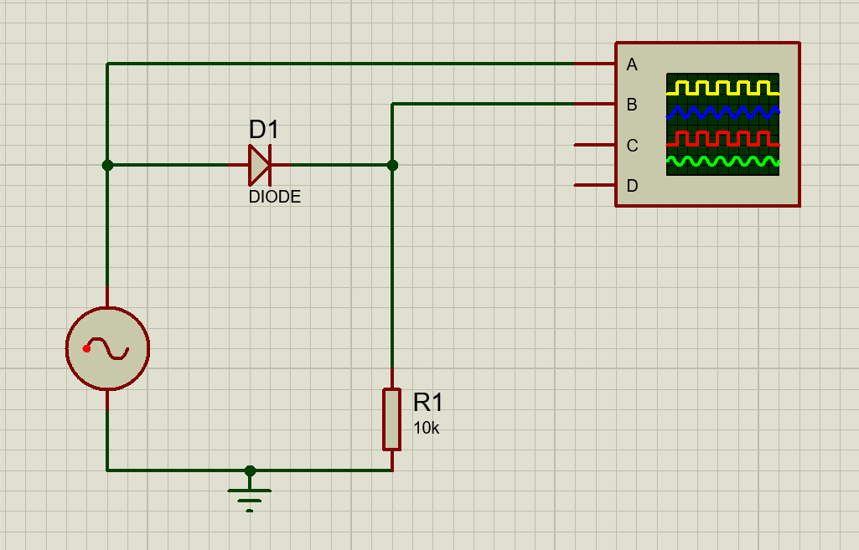

Figure 1.1: Circuit diagram.

**Output:**

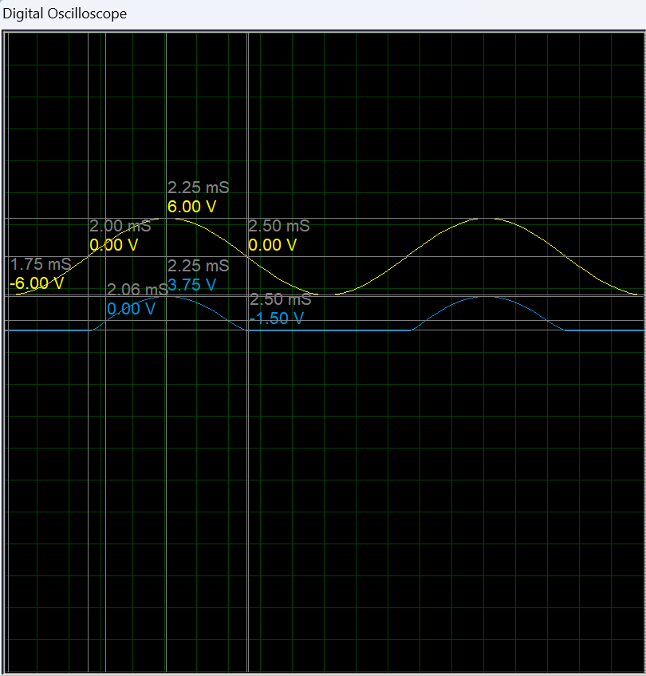

Figure 1.2: Input and output signal in digital oscilloscope

**Discussion:**

In summary, the experiment on the half-wave rectifier yielded results in line with theoretical expectations. The waveform analysis displayed the anticipated pulsating DC output, validating the circuit's functionality.

The measured peak voltage (Vpeak) was consistent with the expected value, affirming the rectifier's efficacy in converting AC to DC. The relationship between the input AC voltage (VAC) and the peak rectified voltage (Vpeak) can be expressed mathematically as:

$V_{peak}= \frac{V_{AC}}{π}$

​

The controlled nature of the simulation, coupled with adherence to precautions, ensured accurate measurements and minimized errors.

The discussion on voltage ripple underscored practical considerations, emphasizing the circuit's applications in power supply. Overall, the experiment enhances our understanding of half-wave rectifiers and provides a foundation for future investigations into advanced rectification techniques.